The Language of Care--Listen
The protagonist of the story is Mr. Chen ,he was an 80-year-old man with dementia. He rarely spoke. Our daily routine was simple: I would check his blood pressure, give him medicine, and help him eat. He would just look out the window, silent.
One day, I was helping him eat lunch. Suddenly, he looked at me and clearly said, "The red blanket... my daughter..." Then he became silent again.
I was surprised. I didn't know what he meant. But I felt it was important. So after my shift, I spoke to his daughter. I learned that Mr. Chen's favorite blanket was a red one his daughter gave him many years ago.
The next day, I brought a red blanket from my home. When I put it on his lap, his eyes changed. He looked at the blanket, then at me, and he smiled. It was a small smile, but it was real.
That moment, I understood something deep. For Mr. Chen, I wasn't just a nurse doing tasks. I was the person who listened to his broken words. I was the one who tried to understand his silent story.
This is the power of narrative nursing. It is not just about medical skills. It is about listening—not only with our ears, but with our hearts. It is about finding the person behind the patient.
In elderly care, our patients have long, beautiful life stories. Sometimes, because of sickness or age, they cannot tell these stories clearly. Our job is to be gentle listeners.We help them feel like themselves again. We help them feel respected and loved.
My story with Mr. Chen is small. But it shows a big truth. When we listen to a patient's story, we build a bridge of trust. This bridge makes our medical care more effective. It also makes our care more human.
This is the real strength of nursing. It is the strength of connection. It is the strength of a simple, shared human moment.
Let us all be story-tellers and story-listeners. Let us continue to speak the language of care, beyond words.
护理的语言-倾听
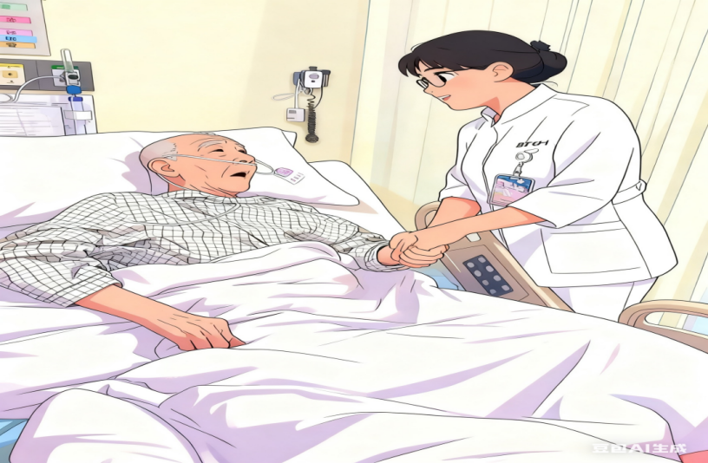

叙事者说：一方红毯，温暖了被遗忘的往事；一次倾听，激起了巨大的涟漪。
故事亮点：这段护理故事始于一次超越常规照护的深度倾听——从患者零落的呢喃中，我敏锐地捕捉到隐藏其下未曾言说的情感渴望。它最终化作一个具体而温情的举动——那条“红毯子”，不仅是对过往记忆的致敬，更成为了连接两颗心灵、重建信任的桥梁。这深刻提醒我们，护理的本质在于看见“病”背后那个完整的“人”，正是通过这样共情的微末介入，我们才能帮助深受失智困扰的老年患者重拾尊严与自我认同。这无疑是对人文关怀最动人的诠释。
本篇作者：


普内科病房 王莹
王莹，北京清华长庚医院普内科病房主管护师，病房护士长，北京护理学会老年专科护士，北京护理学会老年专业委员会青年委员，专业方向为老年护理。

故事的主人公是陈老先生，他年届八旬，罹患认知障碍症，住院期间终日静默无言。我与他的日常相处很简单：协助他测量血压、协助他吃药、协助他进餐。他总是一个人静静地望向窗外，不言不语。

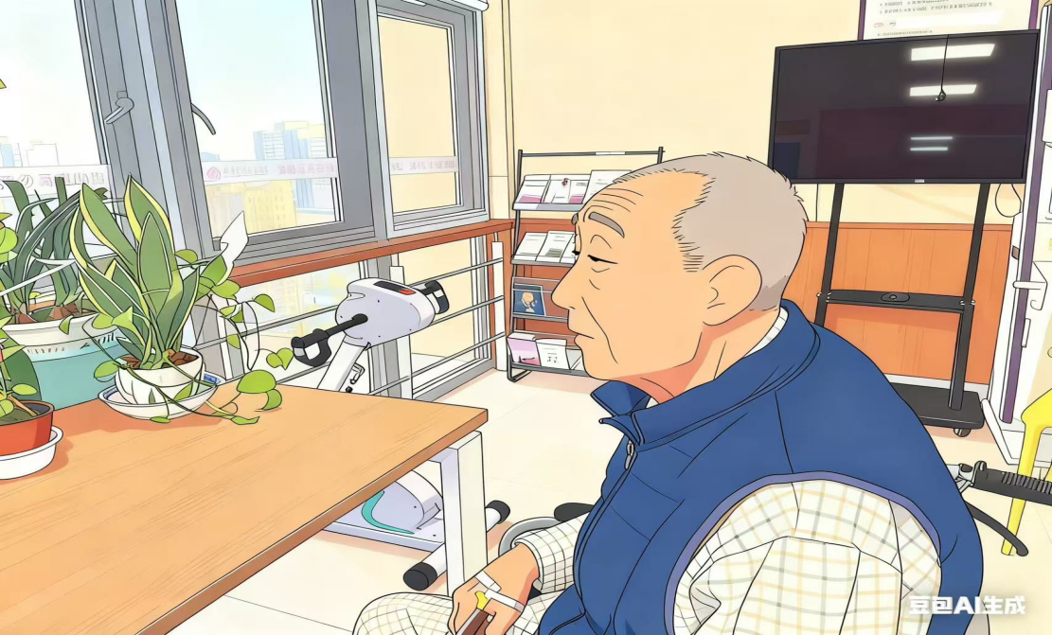
一天，当我协助他进食午餐时，他忽然抬眼望向我，清晰地说出：“红毛毯……我女儿……”而后，复归于沉默。我心下惊诧，不解其意。然而，直觉告诉我，这寥寥数语至关重要。当我下班后，我立即联系了陈老的女儿。这才知晓，原来陈老先生最珍爱的物品，正是女儿多年前赠予他的一条红色毛毯。
第二天，我从家中带来一条红色毛毯。当我将那红色毛毯轻轻覆上他的膝头，他的眼神瞬间变了。他凝视着毛毯，又抬眼望向我，嘴角绽开了一抹微笑。那笑容虽浅，却真挚动人。
就在那一刻，我深深感受到：在陈老心中，我绝非仅是一位执行日常工作的护士，而是那个愿意倾听他破碎言语的人，是那个努力读懂他无声故事的人。
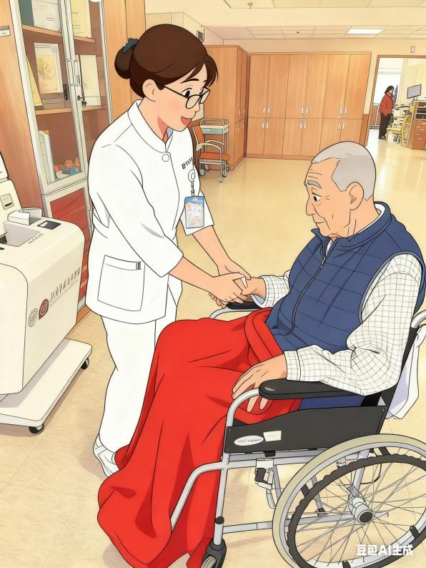

这便是叙事护理的力量。它不仅仅关乎精湛的医疗技术，更关乎倾听——不止于耳闻，更在于心听。倾听帮助我们在患者的身份背后，看见那个鲜活的人。
在老年人照顾过程中，每位长者都有着漫长而精彩的人生故事。然而因疾病与年龄的关系，他们时常无法清晰地讲述这些动人的故事。因此，我们护理人员的重要使命便是成为那耐心而温柔的聆听者。我们助其重拾自我，重获尊严，重感关爱。
我与陈先生的故事虽小，却揭示了一个深刻的道理：当我们在工作中开始倾听患者的故事时，我们便在与患者搭建一座信任的桥梁。这座桥梁让我们的医疗护理工作更加有效，也让我们的照护更具人文温度。这才是护理工作真正的力量所在——是连接的力量，是简单却真挚的人性共鸣的力量。
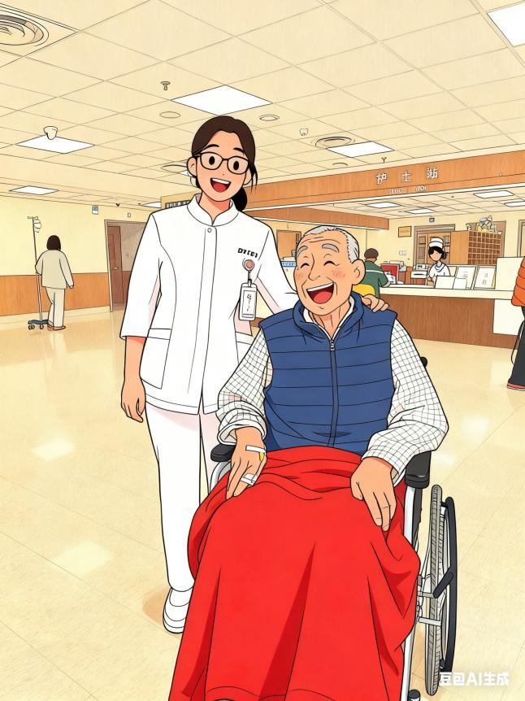

希望我们都成为故事的讲述者与聆听者。愿我们将这份超越言语的关怀之语，永远传递下去。

